**Problem 1:**

**my_DFT:**

function [ output ] = funcDFT( y )

%UNTITLED Summary of this function goes here

% Detailed explanation goes here

y1=ones(length(y),1);

y2=(y1*y)';

N=length(y);

n=[0:N-1];

k=[0:N-1]';

% The result is a 2D array such that

% the columns vary as k varies and rows vary as n varies

h=exp(-i*k*n*2*pi/N);

% Multiply each element in y2 by each element in h

answer=y2.*h;

% We take the sum in row direction ( n direction)

output=sum(answer,1);

% output=sum(answer,2) gives the sum in column direction ( k direction)

end

**Body:**

% create an arbitrary vector

t = 0:1:1000;

y = t;

% Call the function

tic;

profile on;

Result1=funcDFT(y);

profile viewer

toc;

% Comparison with fft

tic;

Result2=fft(y);

toc;

**Results**:

Elapsed time is 0.217952 seconds.

Elapsed time is 0.000055 seconds.

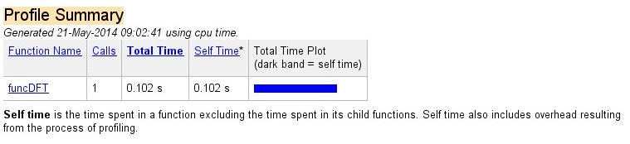

**Problem 2:**

fs = 8000;

To = 0.004;

Ts = 1/fs;

N = 2^nextpow2(To/Ts);

y = zeros(N);

for k = 1:N

y(k+1) = rect((k+1)*Ts);

end

x = linspace(0,To,N);

plot(x,y);

title('RECT');

xlim([0, 5/1000]);

ylim([0,2]);

xlabel('Time domain');

ylabel('Amplitude Spectrum');

**Rect function:**

function outp = rect( x )

max = 2/1000;

if((x < max) && (x > 0))

outp = 1;

else

outp = 0;

end ;

end

**Output**:

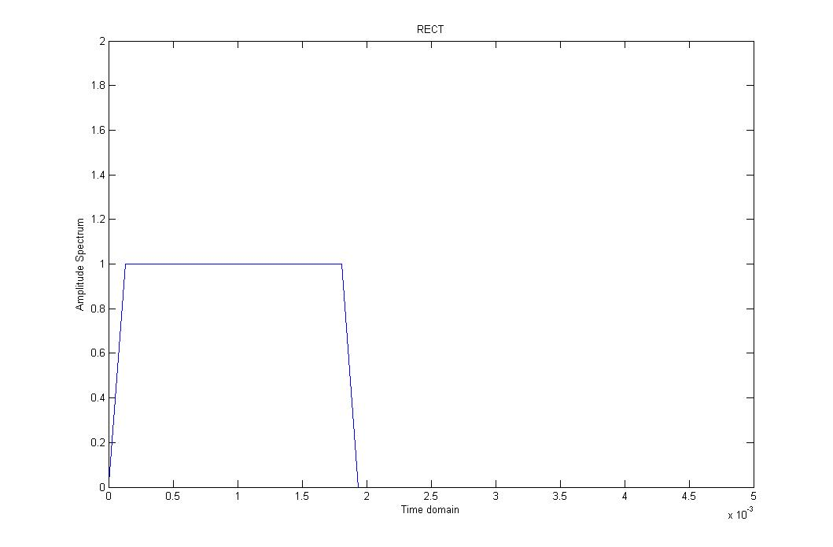

**We need to increase the zeroes ( increase fs ) to increase the resolution.**

**Problem 3:**

hfile='touchtone1.wav';

[y, Fs] = wavread(hfile);

soundsc(y, Fs);

**C:**

t=linspace(0,1/Fs,length(Fs));

figure(1)

plot(t,y);

title('signal in time domain');

xlabel('time');

ylabel('|Y|');

Ts = 1/Fs;

N = length(y)-1;

To = N * Ts;

n=0:Ts:To;

figure(2)

plot(n.*Ts, y);

title('signal in time domain');

xlabel('Time');

ylabel('|Y|');

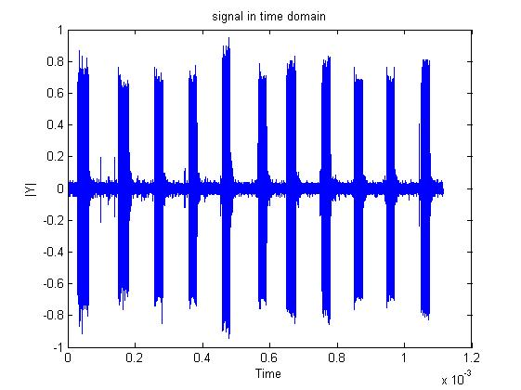

**D:**

f0=1/To;

X=0:f0:Fs;

figure(3)

subplot(2, 1, 1);

plot(X, abs(fft(y)));

title('signal over frequency');

ylabel('|Y|');

xlabel('Angular Frequency');

**Symmetry of the fft around ws/2:**

subplot(2, 1, 2);

plot(X, abs(fft(y)));

xlim ([0 4096]);

title('signal over frequency');

xlabel('Angular Frequency');

ylabel('|Y|');

Yes, the fequencies are obtained.

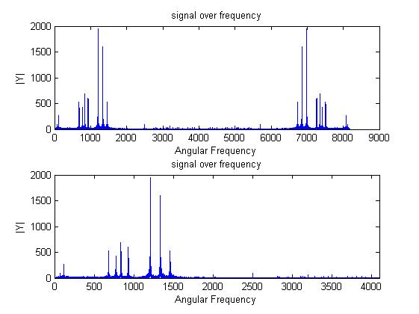

E)

function [tone] = generate_tones( key )

Fs = 8000;

t = 0:1/Fs:(1/2-1/Fs);

num=length(key);

for k=1:num;

value =key(k);

switch value

case{1,2,3}

row = 697;

case{4,5,6}

row = 770;

case{7,8,9}

row = 852;

otherwise

row = 942;

end

switch value

case{1,4,7}

column = 1209;

case{2,3,8,0}

column = 1336;

otherwise

column = 1477;

end

tone = 0.5*(sin(2*pi*row*t)+sin(2*pi*column*t));

sound(tone,Fs);

end

end

F)

function [ tones ] = dial_tones()

Fs=8000;

key = input('Please Dial your number:');

key = num2str(key)

num = length(key);

tones = zeros(1,num*Fs);

time = 0: 1/Fs:(num -1/Fs);

for x = 1:num

tones((1+Fs*(x-1)):(Fs/2 +Fs*(x-1))) = generate_tones(str2num(key(x)));

end

sound(tones,Fs);

%plot(time,tones);

plot(time(1:500),tones(1:500));

title('Dual Signal');

xlabel('Time(sec)');

ylabel('Magnitude');

end

